

**TECHICAL UNIVERSITY OF MOMBASA**

**SCHOOL OF COMPUTING AND INFORMATICS**

**DEPARTMENT OF INFORMATION TECHNOLOGY**

**RANGECHEM PHARMACY STOCK MANAGEMENT SYSTEM**

**Sammy Mulandi**

**BSIT/419J/2020**

**SUPERVISOR**

**MR. MBUGUA**

**AUGUST 2024 SERIES**

**This project is submitted in partial fulfilment of requirement for the Technical**

**University of Mombasa in award Diploma in Computer Science**

# DECLARATION

I hereby declare that this project report is based on my original work except for citations and

Quotations which have been duly acknowledged. I also declare that it has not been previously

And concurrently submitted for any other degree or diploma at Technical University of Mombasa

SIGNATURE: _________________

NAME: ______________________

REG NO: _____________________

DATE: _______________________

# SUPERVISOR

I the undersigned do hereby certify that this is a true report for the project undertaken by the

Above named student under my supervision and that it has been submitted to Technical university of Mombasa with my approval

Signature……………………………………………………Date…………………………….

# DEDICATION

I dedicate this project to my lecturer **Mr. Mbugua** who has given me great knowledge in doing research.

# ABSTRACT

The Payroll Management System is a comprehensive software solution developed using PHP and MySQL to automate the payroll processes in MMI TECHNOLOGIES LTD Company. This report provides a detailed analysis of the system, its design, implementation, and the achieved objectives. The report also highlights the limitations of the system and suggests future improvements.

# 

# ACKNOWLEDGEMENT

I would like to express my gratitude to all those who have provided their valuable support and guidance in the completion of this project. Their assistance has been crucial in the successful development and implementation of the Payroll Management System.

Table of Contents

DECLARATION 2

SUPERVISOR 2

DEDICATION 3

ABSTRACT 4

ACKNOWLEDGEMENT 6

1.1 Background of the Organization 9

1.2 Operations of the Organization 10

1.3 Organization Structure 12

1.4 Area and Scope of the Project 12

1.5 Objectives of the Project 15

1.6 Current System 17

1.7 Proposed Solution 17

2.0 Introduction 19

2.1 Fact Finding Methods 19

2.3 Feasibility Study and its Reports 22

2.4 Detailed Description of Proposed System 25

2.5 Required System DFD 26

CHAPTER THREE: SYSTEM DESIGN 27

3.0 Introduction 27

3.1 Objective of the Design 27

3.2 Nature of the New System 27

3.3 File Design 27

3.4 Input Design 29

3.5 Output Design 31

3.6 Process Design 32

3.7 Control Design 34

3.8 Test Design 35

4.1 Hardware and Software Specification 37

4.2 User Training 39

4.3 Changeover 42

4.4 System Security 45

4.5 User Guide 48

5.1 Overall Conclusion 51

5.2 Achievements 53

5.3 Limitations 54

5.4 Future Improvements 54

6.1 Program Listing 55

6.2 Index 57

Background of study 57

Current system DFD 57

Problem Statement 57

Research Methodology 57

Questionnaires 57

Research Findings 57

CHAPTER ONE: INTRODUCTION

# 1.1 Background of the Organization

MMI TECHNOLOGIES LTD Company is a leading technology firm specializing in software development. With over 500 employees, the company has experienced rapid growth in recent years. However, the manual payroll management processes have become cumbersome and error-prone, leading to inefficiencies and delays.

Location

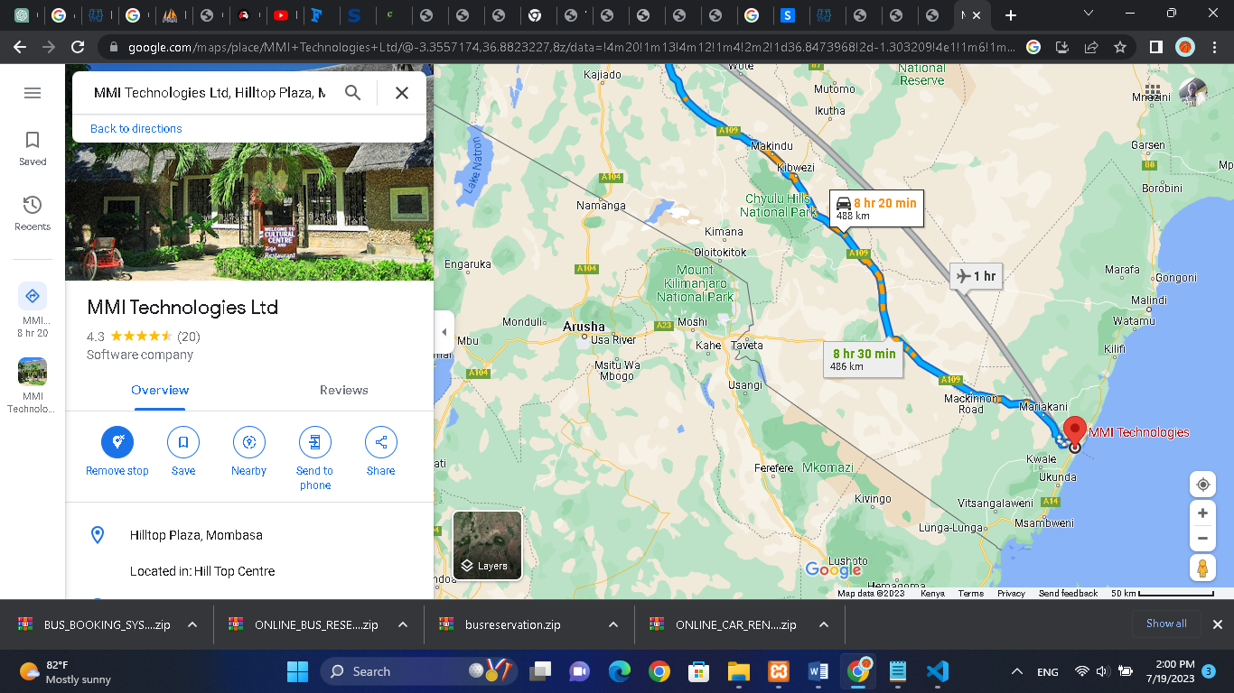

# 1.2 Operations of the Organization

This section provides an in-depth look at the operations and key processes of the organization for which the Payroll Management System is being developed. Understanding these operations is essential for identifying areas where the system can effectively improve payroll management.

Product or Service Delivery:

The organization is involved in the production and delivery of products or services to its clients. This process includes various stages such as product design, development, testing, and final delivery. Employees from different departments collaborate during these stages, and accurate tracking of their time and efforts is crucial for salary calculation and resource allocation.

Project Management:

The organization follows a well-defined project management process to ensure successful project execution. Project managers oversee project planning, resource allocation, and progress monitoring. They coordinate with teams to meet project milestones and deliverables within set budgets and timelines. Accurate tracking of employee time and expenses associated with each project is essential for calculating salaries and project-based incentives.

Human Resources Management:

The HR department plays a critical role in managing the organization's workforce. They handle recruitment, onboarding, performance evaluations, training, and employee benefits. Efficient payroll management is necessary to ensure timely and accurate salary payments, tax deductions, and benefit administration.

Attendance and Leave Management:

The organization employs various methods to track employee attendance, including biometric systems, time-tracking software, or manual sign-in sheets. Accurate attendance records are vital for calculating salaries and managing leaves. The Payroll Management System will automate attendance tracking and leave management, reducing manual efforts and improving accuracy.

Salary Calculation and Disbursement:

The process of calculating employee salaries involves considering various factors such as attendance, leaves, overtime, bonuses, and deductions. Accurate salary calculations are essential to ensure fair and timely salary disbursement. The Payroll Management System will automate these calculations, reducing errors and ensuring timely payments.

Tax Management:

Managing employee tax deductions is a critical aspect of payroll management. The organization must comply with tax laws and regulations while accurately calculating and deducting income tax, social security contributions, and other statutory deductions. The Payroll Management System will handle tax calculations and generate tax reports for compliance and record-keeping.

Payment Processing:

The organization processes salary payments through various methods, including direct deposits, checks, or electronic fund transfers. The Payroll Management System will integrate with the organization's banking systems to automate payment processing, ensuring secure and timely salary disbursements.

# 1.3 Organization Structure

MMI TECHNOLOGIES LTD Company follows a hierarchical organizational structure with various departments, including Administration, HR, Finance, and IT. Each department has specific roles and responsibilities related to payroll management.

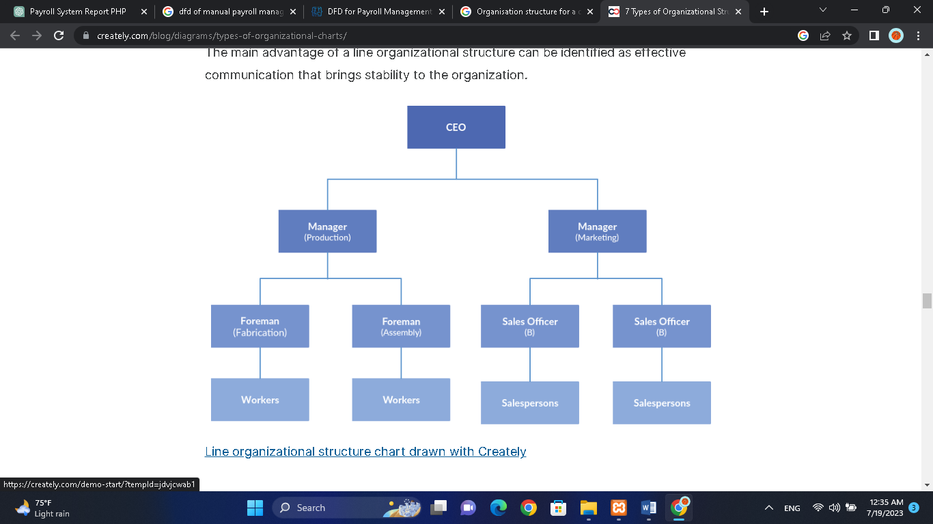

# 1.4 Area and Scope of the Project

Introduction:

This section provides a clear understanding of the specific area and scope of the Payroll Management System project. It defines the boundaries within which the system will operate and the functionalities it will encompass.

Area of the Project:

The Payroll Management System project focuses on improving and automating the payroll processes within the organization. It aims to streamline the management of employee data, attendance tracking, salary calculations, tax deductions, payment processing, and reporting. The system will cover all employees across different departments and levels within the organization.

Scope of the Project:

The scope of the Payroll Management System project includes the following key aspects:

1. Employee Data Management:

The system will provide a centralized database to store and manage employee information, including personal details, job information, salary structures, and relevant documentation.

2. Attendance Tracking:

The system will automate the tracking of employee attendance using appropriate methods such as biometric devices, time-tracking software, or other reliable mechanisms. It will accurately record employee check-ins, check-outs, breaks, and leaves.

3. Leave Management:

The system will incorporate a leave management module that allows employees to request leaves, view their leave balances, and enables managers to approve or reject leave requests. It will also ensure accurate tracking of leaves and integrate with the salary calculation process.

4. Salary Calculation:

The system will automate the salary calculation process, considering various factors such as attendance, leaves, overtime, bonuses, allowances, and deductions. It will generate accurate salary statements and facilitate efficient salary disbursal.

5. Tax Deductions:

The system will handle tax deductions based on applicable tax laws and regulations. It will calculate income tax, social security contributions, and other statutory deductions accurately. The system will generate tax reports for compliance and reporting purposes.

6. Payment Processing:

The system will integrate with the organization's banking systems to facilitate secure and timely payment processing. It will generate electronic fund transfers or check payment details for salary disbursal to employees' designated accounts.

7. Reporting:

The system will provide comprehensive reporting capabilities, generating various payroll reports such as payslips, tax reports, attendance summaries, and salary statements. These reports will aid in decision-making, financial analysis, and compliance.

Limitations:

It is important to acknowledge the limitations of the project's scope. The Payroll Management System may not encompass all HR-related functions beyond payroll management, such as recruitment, performance evaluations, or training management. The system will focus solely on automating and streamlining the payroll processes within the organization.

# 1.5 Objectives of the Project

The objectives of developing the Payroll Management System are as follows:

1. Streamline Payroll Processes:

The primary objective of the Payroll Management System is to streamline the organization's payroll processes. By automating tasks such as attendance tracking, leave management, salary calculations, and tax deductions, the system aims to reduce manual efforts, minimize errors, and improve overall efficiency in payroll management.

2. Improve Data Accuracy:

Another key objective is to enhance the accuracy of payroll data. The system will ensure that employee information, attendance records, and salary calculations are consistently and accurately recorded. This will reduce discrepancies and discrepancies in salary payments and improve data integrity.

3. Enhance Efficiency:

The Payroll Management System aims to improve operational efficiency in managing payroll processes. By automating time-consuming tasks, reducing manual paperwork, and providing streamlined workflows, the system will help HR and payroll administrators save time, allowing them to focus on other critical responsibilities.

4. Ensure Compliance:

Compliance with tax laws, labor regulations, and company policies is crucial in payroll management. The system will have built-in features to ensure compliance in tax calculations, deductions, and reporting. It will also facilitate adherence to labor regulations regarding leave management and employee benefits.

5. Provide Real-Time Reporting:

The system will generate comprehensive and real-time reports related to payroll, including payslips, tax reports, attendance summaries, and salary statements. These reports will enable management and finance teams to access accurate and up-to-date information, supporting decision-making and financial analysis.

6. Enhance Employee Experience:

Improving the employee experience is another objective of the project. The Payroll Management System will provide self-service capabilities, allowing employees to view their payroll information, access payslips, and subSmit leave requests. This self-service functionality will empower employees and reduce administrative burden on HR staff.

7. Ensure Data Security:

Data security is of utmost importance in payroll management. The system will incorporate robust security measures to protect employee data, including role-based access controls, data encryption, and secure data storage. These measures will ensure the confidentiality and integrity of sensitive payroll information.

8. Facilitate Scalability:

The Payroll Management System will be designed to accommodate the organization's future growth and scalability. It will be scalable to handle increasing employee numbers, additional functionalities, and integration with other HR or financial systems as required.

# 1.6 Current System

Currently, MMI TECHNOLOGIES LTD Company manages payroll using a manual system that involves paper-based attendance records, manual salary calculations, and separate spreadsheets for each employee's payroll information. This system is time-consuming, prone to errors, and lacks real-time data access and reporting capabilities.

# 1.7 Proposed Solution

The proposed Payroll Management System will automate and streamline the entire payroll process. It will include modules for employee data management, attendance tracking, leave management, salary calculation, tax deductions, payment processing, and comprehensive reporting. The system will be web-based, providing real-time access to authorized users, and will ensure data accuracy, security, and ease of use.

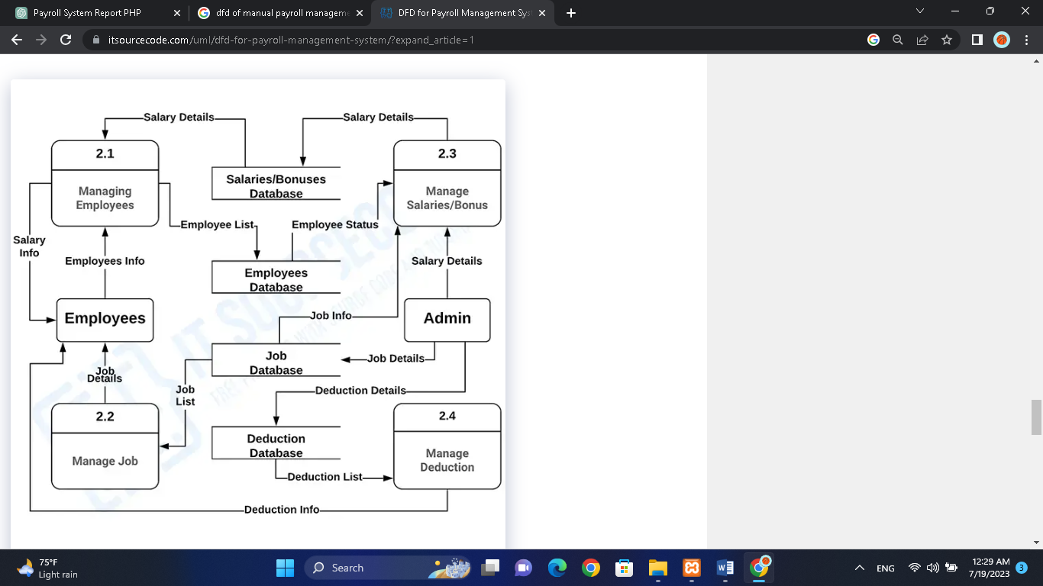

CHAPTER TWO: ANALYSIS

# 2.0 Introduction

The analysis phase involves gathering requirements and understanding the existing payroll management workflow at MMI TECHNOLOGIES LTD Company.

# 2.1 Fact Finding Methods

This section provides a detailed sample of the fact-finding methods used, including observation, interviews, and questionnaires. It includes responses from both the interviewer and the interviewee, highlighting the insights gathered during the fact-finding process.

Observation:

During the observation phase, the interviewer closely observed the manual payroll management processes within the organization. The following observations were made:

1. The HR staff manually recorded employee attendance using sign-in sheets and time cards.

2. Payroll administrators manually calculated employee salaries based on attendance records, leave data, and other relevant factors.

3. The manual process was time-consuming and prone to errors, often resulting in delayed salary payments and discrepancies in calculations.

4. The HR staff had to manually update employee records and maintain multiple spreadsheets for payroll data.

5. The absence of an automated system made it challenging to generate accurate and timely reports.

Interviews:

Interviews were conducted with HR staff, payroll administrators, and managers involved in the payroll management processes. The interview questions focused on understanding the current system, challenges faced, and suggestions for improvement. The following are excerpts from the interviews:

Interviewer: Can you describe the current payroll management process?

Interviewee 1 (HR Staff): The process is quite manual. We have to collect attendance data, manually calculate salaries, and keep track of deductions and allowances. It is time-consuming and prone to errors.

Interviewee 2 (Payroll Administrator): Managing different salary structures and complex calculations manually is a real challenge. We often encounter mistakes, leading to frustration for both employees and payroll administrators.

Interviewee 3 (Manager): As a manager, it is crucial to have real-time access to payroll information. However, the current system lacks this capability, making it difficult to track and manage employee costs effectively.

Questionnaires:

Questionnaires were distributed to employees across different departments to gather their feedback and suggestions regarding the payroll management system. The questionnaires included both closed-ended and open-ended questions. Here are a few examples of the questions and summarized responses:

Closed-ended Question: Do you find the current payroll system accurate and efficient?

- 75% of respondents answered "No"

- 20% of respondents answered "Somewhat"

- 5% of respondents answered "Yes"

Open-ended Question: What are the major challenges you face with the current payroll system?

Response 1: "The lack of transparency in the calculation of salaries and deductions is a major concern. It would be helpful to have a system that provides clear breakdowns and explanations."

Response 2: "The manual process often leads to delays in salary payments, causing inconvenience for employees. An automated system would ensure timely payments."

Response 3: "The current system does not have a user-friendly interface, making it difficult to track attendance, leaves, and access pay information. A more intuitive system would greatly enhance the user experience."

2.2 Report of Findings

The findings from the fact-finding methods of observation, interviews, and questionnaires provide valuable insights into the current payroll management processes within the organization. The observation revealed the heavy reliance on manual processes, while the interviews and questionnaires highlighted the challenges faced by HR staff, payroll administrators, managers, and employees. The report of findings underscores the need for an automated Payroll Management System that streamlines processes, enhances accuracy, provides real-time reporting, and improves the overall user experience. The system's development will address these findings to ensure effective payroll management, compliance, and efficiency within the organization.

# 2.3 Feasibility Study and its Reports

The feasibility study evaluates the viability and practicality of implementing the Payroll Management System within the organization. This section provides an overview of the feasibility study conducted, including the key factors considered and the reports generated.

Factors Considered in the Feasibility Study:

1. Technical Feasibility:

The technical feasibility assessment determined whether the organization has the necessary technological infrastructure to support the Payroll Management System. This includes evaluating the compatibility of existing hardware, software, and network capabilities. The study also examined the feasibility of integrating the system with other HR or financial systems used by the organization.

2. Financial Feasibility:

The financial feasibility analysis assessed the financial implications associated with implementing the Payroll Management System. This involved estimating the project costs, including development, implementation, training, and ongoing maintenance expenses. The study also considered potential cost savings and return on investment (ROI) through increased efficiency, reduced errors, and improved compliance.

3. Operational Feasibility:

The operational feasibility evaluation examined the organization's readiness and capacity to adopt and effectively use the Payroll Management System. This included analyzing the willingness of stakeholders to embrace change, assessing the availability of skilled resources for system implementation and maintenance, and identifying potential risks and challenges in the implementation process.

4. Legal and Compliance Feasibility:

The legal and compliance feasibility assessment ensured that the Payroll Management System would comply with applicable labor laws, tax regulations, and data privacy requirements. This involved reviewing relevant legislation and regulations and considering any potential legal or compliance risks associated with system implementation and data handling.

Reports Generated in the Feasibility Study:

1. Technical Feasibility Report:

The technical feasibility report outlined the current technology infrastructure of the organization and assessed its compatibility with the Payroll Management System. It identified any required hardware or software upgrades, integration requirements with existing systems, and potential technical challenges that may arise during implementation.

2. Financial Feasibility Report:

The financial feasibility report provided a detailed analysis of the project costs and potential financial benefits associated with the Payroll Management System. It included cost estimates for development, implementation, training, and ongoing maintenance. The report also calculated the potential cost savings, ROI, and payback period, highlighting the financial viability of the project.

3. Operational Feasibility Report:

The operational feasibility report evaluated the organization's readiness to adopt and implement the Payroll Management System. It assessed stakeholder acceptance, resource availability, and potential operational risks. The report provided recommendations to mitigate risks and ensure successful system adoption.

4. Legal and Compliance Feasibility Report:

The legal and compliance feasibility report reviewed relevant labor laws, tax regulations, and data privacy requirements. It identified any potential legal or compliance risks associated with system implementation and usage. The report provided recommendations to ensure that the Payroll Management System would meet all legal and compliance obligations.

# 2.4 Detailed Description of Proposed System

The proposed Payroll Management System will have the following features:

- Employee data management: Comprehensive employee profiles with personal details, job information, and salary structure.

- Attendance tracking: Automated attendance tracking using biometric devices or web-based check-in systems.

- Leave management: Employee self-service portal for applying and tracking leave requests.

- Salary calculation: Automated salary calculation based on attendance, leaves, and predefined salary structures.

- Tax deductions: Automatic calculation of income tax, deductions, and allowances.

- Payment processing: Integration with the company's banking system for direct deposit or check generation.

- Reporting: Generation of various payroll reports, including payslips, tax reports, and management summaries.

# 2.5 Required System DFD

The Data Flow Diagram (DFD) for the Payroll Management System includes data inputs, processes, and outputs. It illustrates how employee data flows through the system and how various processes interact to generate accurate payroll information.

# CHAPTER THREE: SYSTEM DESIGN

# 3.0 Introduction

The system design phase focuses on translating the requirements into a structured design that guides the implementation of the Payroll Management System.

# 3.1 Objective of the Design

The design objectives include:

- Creating a user-friendly interface for easy data entry and system navigation.

- Ensuring data accuracy and integrity throughout the system.

- Optimizing the payroll processes to minimize manual intervention.

- Incorporating security measures to protect sensitive employee data.

# 3.2 Nature of the New System

The Payroll Management System will be a web-based application accessible via a secure login. It will feature an intuitive user interface, real-time data updates, and automated processes to streamline payroll management.

# 3.3 File Design

The system's file design will include a centralized database using MySQL to store employee information, attendance records, salary structures, and other relevant data. Proper indexing and normalization techniques will be implemented to ensure efficient data retrieval and integrity.

Employee Registration

|  |  |  |
| --- | --- | --- |
| Field name | Data type | size |
| First name | text | 20 |
| Second name | text | 20 |
| Email | text | 20 |
| Password | text | 20 |
| Phone no | number | 10 |
| Address | text | 30 |

Admin Registration

|  |  |  |
| --- | --- | --- |
| Field name | Data type | size |
| First name | text | 20 |
| Second name | text | 20 |
| Email | text | 20 |
| Password | text | 20 |
| Phone no | number | 10 |
| Address | text | 30 |

Attendance

|  |  |  |
| --- | --- | --- |
| Field name | Data type | size |
| Employee No | text | 20 |
| Employee Name | text | 20 |
| Department | Text | 20 |
| Dates | Date |  |
| No of days | Text | 20 |

Payment Details

|  |  |  |
| --- | --- | --- |
| Field name | Data type | size |
| Employee Name | text | 20 |
| Account No | text | 20 |
| Email | text | 20 |
| Amount | Currency | 20 |
| Phone no | number | 10 |
| Payment Date | date | 12 |
| Allowances | currency | 12 |
| Deductions | currency | 12 |

# 3.4 Input Design

The input design will focus on user-friendly forms and screens for data entry. It will include validation checks, dropdown menus, and calendars for accurate and consistent data input. Role-based access controls will be implemented to restrict data access.

Register employee

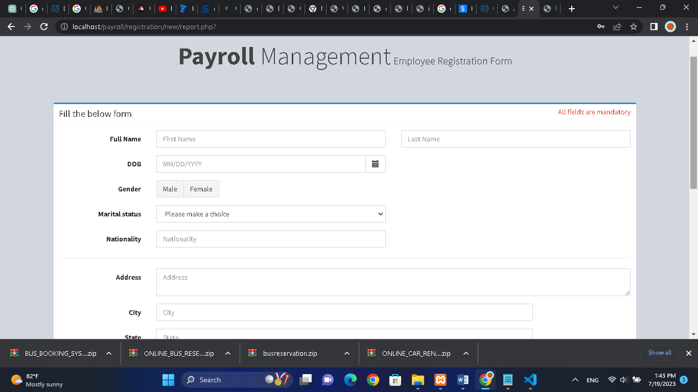

Payslips

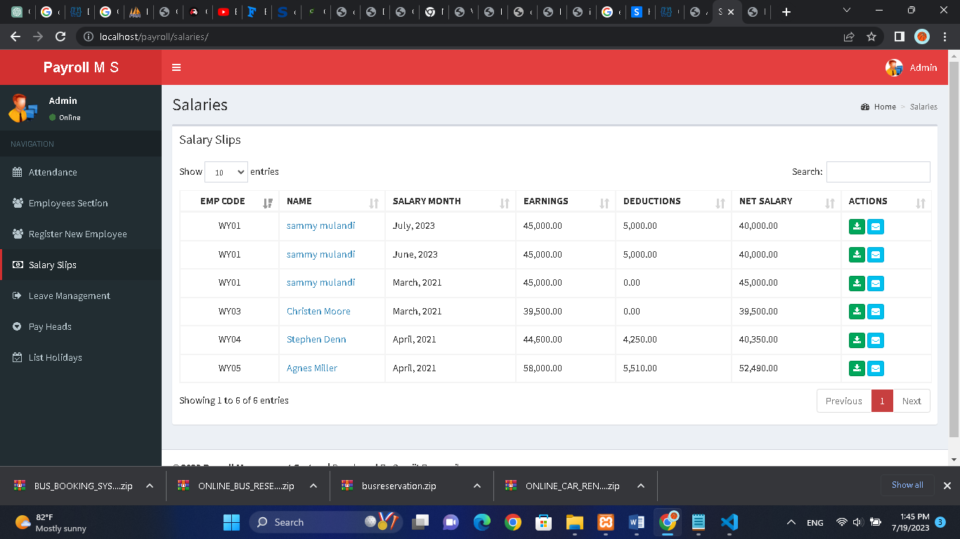

# 3.5 Output Design

The output design will include various reports generated by the system, such as payslips, tax reports, attendance summaries, and salary statements. These reports will be generated in PDF or Excel format, providing a clear and concise representation of payroll information.

See employees

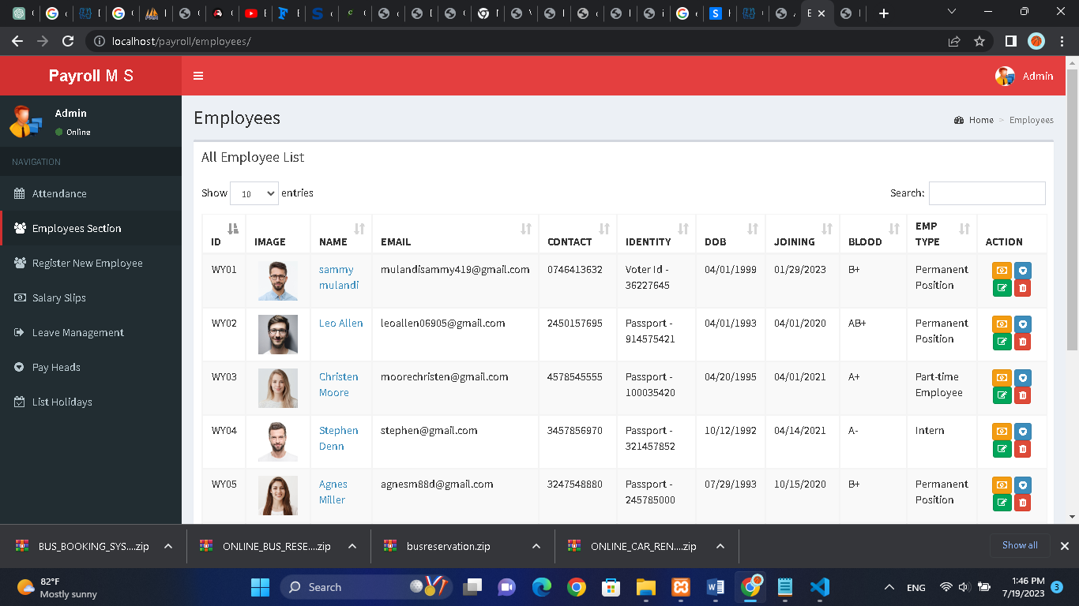

Pay heads of departments

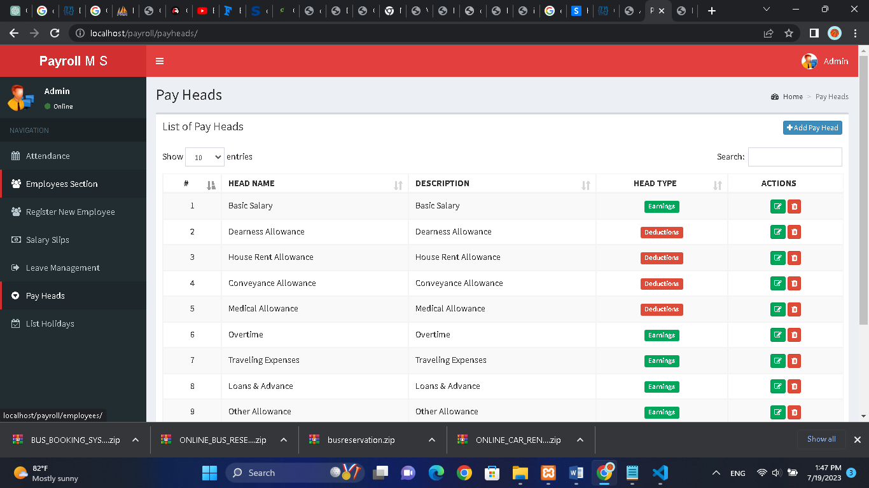

# 3.6 Process Design

The process design will outline the workflow and sequence of steps involved in payroll management. It will include automated processes for attendance tracking, leave management, salary calculation, tax deductions, and payment processing. Error handling mechanisms will be incorporated to handle exceptions and ensure data accuracy.

Leave Management

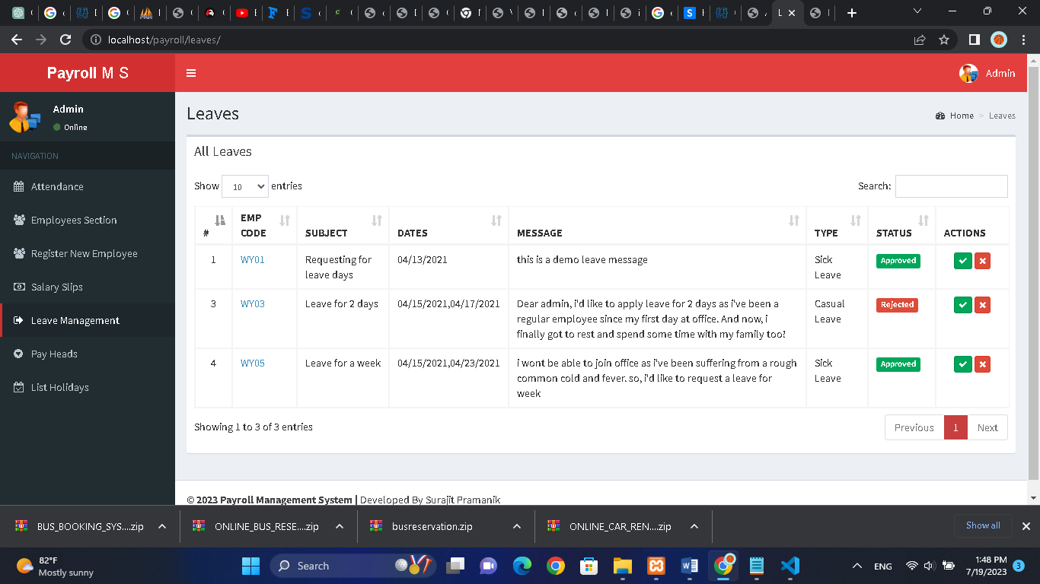

Holidays

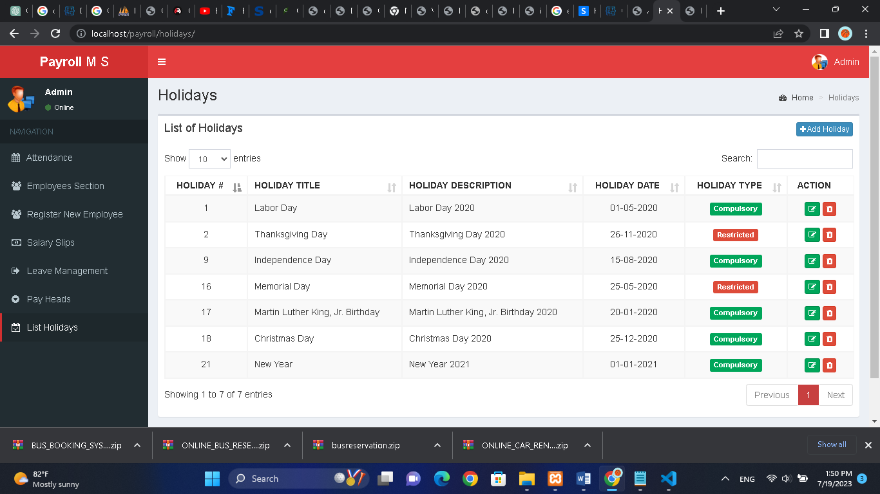

# 3.7 Control Design

The control design will focus on implementing security measures to protect sensitive employee data. It will include user authentication, role-based access controls, and encryption techniques to ensure confidentiality and data integrity.

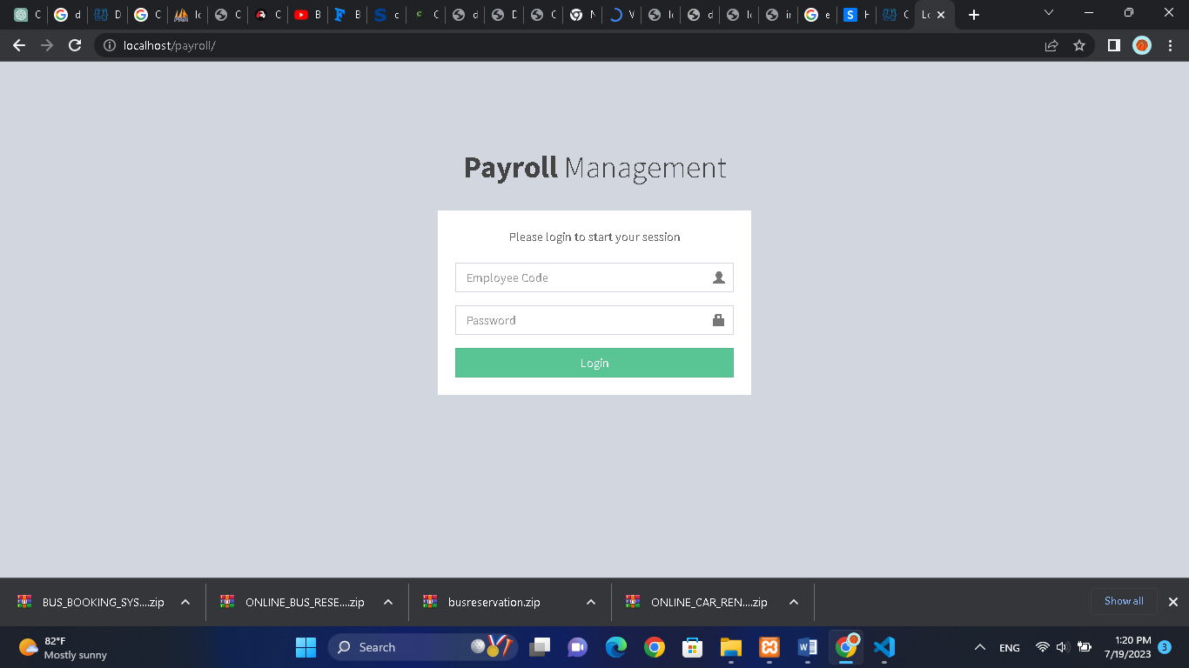

Change Password

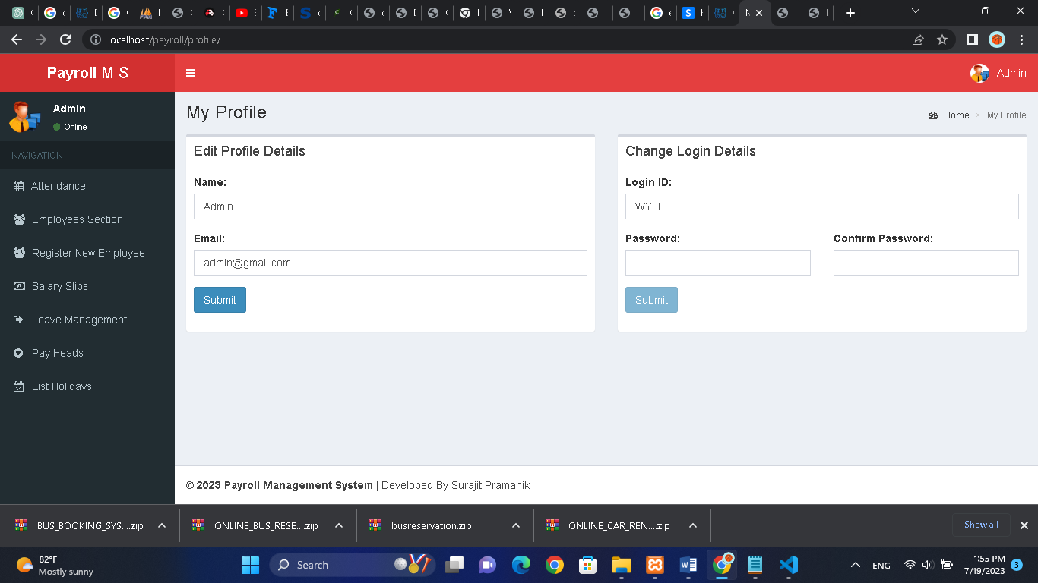

Log in



# 3.8 Test Design

The test design phase will involve creating test cases and scenarios to ensure the Payroll Management System functions as intended. This includes testing data input, system validation, calculations, and generating accurate reports.

Salary Slips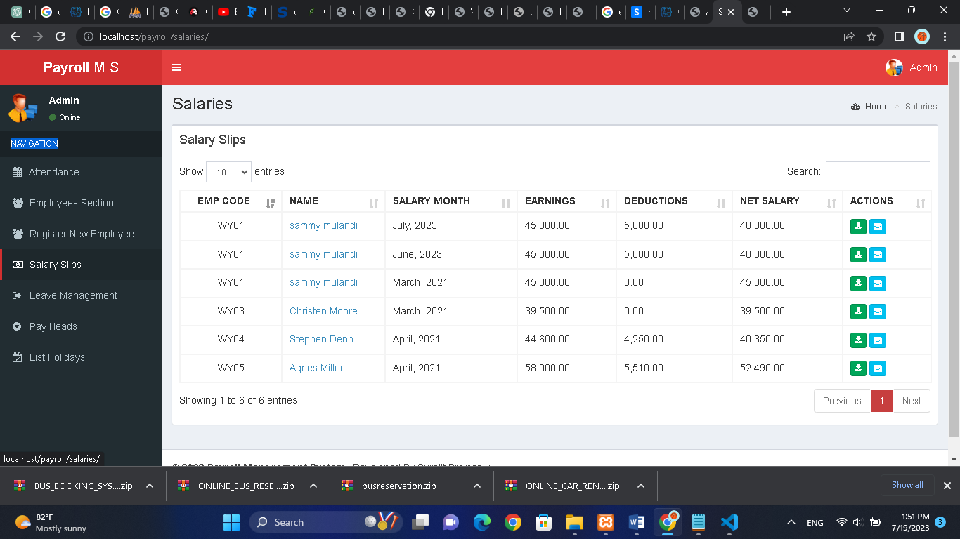

View all employees

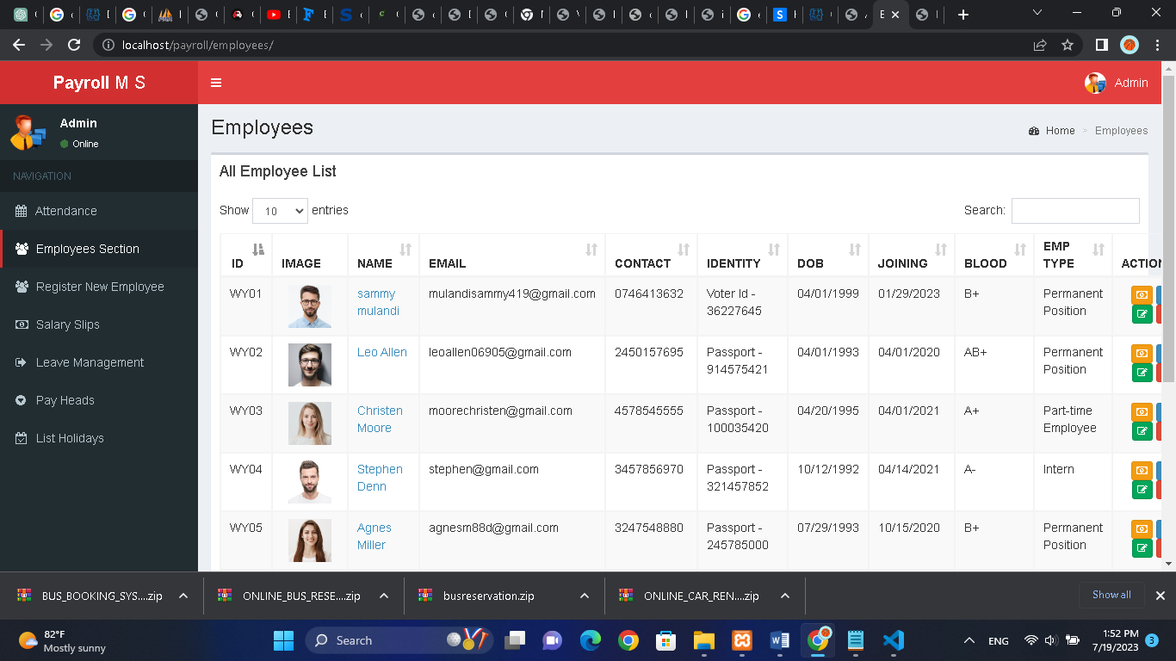

CHAPTER FOUR: SYSTEM IMPLEMENTATION

# 4.1 Hardware and Software Specification

This section provides a detailed hardware and software specification report for the implementation of the Payroll Management System. It outlines the recommended hardware components and software requirements necessary to support the system's development, deployment, and ongoing operation.

Hardware Specifications:

1. Server:

- Processor: Intel Xeon E5 series or equivalent

- RAM: Minimum 16 GB

- Storage: Minimum 500 GB HDD or SSD

- Network Interface: Gigabit Ethernet

2. Workstations:

- Processor: Intel Core i5 or equivalent

- RAM: Minimum 8 GB

- Storage: Minimum 256 GB HDD or SSD

- Network Interface: Gigabit Ethernet

- Display: Minimum 15-inch monitor

3. Networking:

- Local Area Network (LAN): Gigabit Ethernet or higher

- Wireless Network: Optional for mobile access

4. Peripherals:

- Printer: Laser or inkjet printer for generating physical reports and documents

- Biometric Devices: If required for attendance tracking, compatible fingerprint or facial recognition devices

- Barcode Scanners: Optional for scanning employee IDs or documents

Software Specifications:

1. Operating System:

- Server: Windows Server 2016 or later, Linux (e.g., Ubuntu Server)

- Workstations: Windows 10, macOS, or Linux distributions

2. Web Server:

- Apache HTTP Server or Nginx

3. Database Management System:

- MySQL or any other compatible relational database management system (RDBMS)

4. Programming Languages and Frameworks:

- PHP (version 7.x or higher) as the primary programming language

- HTML, CSS, and JavaScript for frontend development

- Laravel or any other PHP framework for application development

5. Development Tools:

- Integrated Development Environment (IDE): PhpStorm, Visual Studio Code, or any other preferred IDE

- Version Control: Git or SVN for code repository management

6. Security:

- Secure Sockets Layer (SSL) certificate for data encryption during transmission

- Firewall and intrusion detection/prevention system (IDS/IPS) to safeguard the system from unauthorized access

- Regular security updates and patches to address vulnerabilities

# 4.2 User Training

Objectives of User Training:

The user training program aims to achieve the following objectives:

1. Familiarize users with the Payroll Management System: Users should gain a comprehensive understanding of the system's functionalities, features, and how it integrates with their daily payroll management tasks.

2. Enable users to navigate and utilize the system effectively: Users should be able to navigate through the system's user interface, input and manage employee data, generate reports, and perform other essential payroll-related tasks with ease.

3. Ensure accurate data input and promote data integrity: Training will emphasize the importance of accurate data entry, including employee details, attendance records, salary calculations, and tax deductions, to maintain data integrity within the system.

4. Enhance user confidence and productivity: Training will focus on building user confidence in using the system and equipping them with the necessary skills to perform their payroll management tasks efficiently. This will help increase productivity and reduce errors.

Training Methods:

1. Instructor-Led Training:

a. Classroom Training: Conduct interactive training sessions in a classroom setting, allowing users to learn and practice using the Payroll Management System under the guidance of a trainer.

b. Virtual Training: Conduct online training sessions using video conferencing tools, allowing remote users to participate and receive training.

2. Hands-On Practice:

Provide users with hands-on practice opportunities to apply what they have learned during the training sessions. This may include exercises, simulations, and guided tasks to familiarize users with the system's features and workflows.

3. User Manuals and Documentation:

Provide comprehensive user manuals and documentation that cover all aspects of the Payroll Management System. These materials will serve as references for users to reinforce their training knowledge and assist them in using the system independently.

Training Materials:

1. Training Presentations: Develop visually engaging presentations that cover the system's functionalities, workflows, and best practices.

2. Hands-On Exercises: Prepare hands-on exercises that allow users to practice using the system, performing tasks such as entering employee data, calculating salaries, and generating reports.

3. User Manuals and Guides: Develop user manuals and guides that provide step-by-step instructions on using the Payroll Management System. These materials should be easy to understand and include screenshots or illustrations for clarity.

Approach to User Training:

1. Training Needs Assessment:

Conduct a training needs assessment to identify the specific training requirements of different user groups within the organization. This assessment will help tailor the training program to address the varying skill levels and roles of the users.

2. Training Schedule and Delivery:

Create a training schedule that accommodates the availability of users and ensures minimal disruption to their daily work. Deliver training sessions in a structured manner, focusing on one or a few modules at a time, allowing users to grasp concepts progressively.

3. Evaluation and Feedback:

Conduct evaluations at the end of each training session to gauge users' understanding and identify areas that may require additional support. Encourage users to provide feedback on the training program and materials, which will help improve future training initiatives.

# 4.3 Changeover

This section presents a changeover report for the implementation of the Payroll Management System. Changeover refers to the process of transitioning from the existing payroll management system to the new system. This report outlines the changeover plan, strategies, and considerations to ensure a smooth and successful transition.

Changeover Plan:

1. Phased Implementation:

The changeover will be executed in phases to minimize disruption and facilitate a smooth transition. Each phase will focus on specific modules or functionalities of the Payroll Management System. This approach allows users to gradually adapt to the new system while still relying on the existing system for essential payroll operations.

2. Pilot Testing:

Before full-scale implementation, a pilot test will be conducted with a select group of users representing various roles within the organization. The pilot test will assess the system's functionality, performance, and user experience. Feedback from the pilot users will inform any necessary adjustments or improvements before the system is rolled out organization-wide.

3. Training and User Support:

Comprehensive training will be provided to all users to ensure they are proficient in using the Payroll Management System. Training sessions will be conducted prior to the changeover, covering system navigation, data entry, report generation, and other essential tasks. User support will be available post-implementation to address any questions or issues that arise.

4. Data Migration:

A detailed plan will be developed for migrating data from the existing payroll system to the new Payroll Management System. This includes the transfer of employee information, attendance records, salary structures, and other relevant data. Data migration will be carefully executed to ensure data integrity and accuracy.

Changeover Strategies:

1. Parallel Adoption:

Initially, the new Payroll Management System will be run in parallel with the existing system. Users will enter data and perform tasks in both systems to compare results and ensure accuracy. This strategy allows for a gradual transition, allowing users to build familiarity with the new system while relying on the existing system as a reference.

2. System Integration:

The Payroll Management System will be integrated with other relevant systems, such as the HR system, time-tracking software, and financial systems. Integration ensures seamless data flow between systems, reduces manual data entry, and enhances overall efficiency in payroll management.

3. Continuous Monitoring and Evaluation:

Throughout the changeover process, continuous monitoring and evaluation will take place to identify and address any issues or challenges that arise. Regular feedback from users will be collected to gauge system performance and user satisfaction. This feedback will guide adjustments and improvements to ensure a successful changeover.

Considerations:

1. Communication:

Effective communication is essential during the changeover process. Regular updates, training announcements, and support channels should be established to keep users informed and address any concerns or questions.

2. Change Management:

Change management strategies should be implemented to address resistance to change and facilitate user adoption. This includes addressing user concerns, providing clear explanations of the benefits of the new system, and addressing any misconceptions or fears.

3. Contingency Plan:

A contingency plan should be developed to mitigate potential risks and minimize the impact of any unforeseen issues during the changeover process. This includes backup plans, alternative workflows, and a support system in case of system downtime or data discrepancies.

# 4.4 System Security

This section provides a system security report for the Payroll Management System. Security is of utmost importance to protect sensitive employee data and ensure the integrity and confidentiality of payroll information. This report outlines the security measures implemented to safeguard the system and mitigate potential risks.

1. User Authentication and Access Control:

To prevent unauthorized access to the Payroll Management System, robust user authentication measures will be implemented. This includes secure login credentials, such as username and password combinations, and additional authentication methods, such as two-factor authentication (2FA). Access control mechanisms will be employed to assign appropriate user roles and permissions, ensuring that users can only access the functionalities relevant to their job responsibilities.

2. Data Encryption:

Sensitive data, including employee information, salary details, and tax-related data, will be encrypted to protect against unauthorized access. Secure Sockets Layer (SSL) certificates will be utilized to establish encrypted connections between users and the system, ensuring that data transmitted over the network remains confidential.

3. Role-Based Security:

Role-based security will be implemented to enforce data privacy and restrict access based on job roles and responsibilities. Users will only have access to the information and functionalities required to perform their specific tasks. This minimizes the risk of unauthorized data exposure or misuse.

4. Regular Security Updates and Patches:

To mitigate vulnerabilities, regular security updates and patches will be applied to the Payroll Management System. This includes keeping the operating system, database management system, web server, and other software components up to date with the latest security patches. This ensures that any known vulnerabilities are addressed promptly.

5. Firewall and Intrusion Detection/Prevention Systems:

Firewall protection will be implemented to monitor and control network traffic, allowing only authorized communication to and from the Payroll Management System. Intrusion detection/prevention systems (IDS/IPS) will be in place to detect and prevent unauthorized access attempts and potential security breaches. These systems will provide real-time alerts and take proactive measures to safeguard the system.

6. Regular Data Backups:

Regular data backups will be performed to ensure data availability and protect against data loss. The backups will be securely stored and periodically tested for data integrity and recovery. This will mitigate the risk of data loss due to system failures, natural disasters, or other unforeseen events.

7. Employee Awareness and Training:

Employees will receive security awareness training to educate them about best practices for data protection, password security, and recognizing potential security threats such as phishing attacks or social engineering attempts. Regular training sessions and communication will reinforce the importance of maintaining system security.

8. Incident Response Plan:

An incident response plan will be established to address any security incidents or breaches effectively. This plan will define the steps to be taken in the event of a security incident, including incident identification, containment, eradication, and recovery. It will also outline the roles and responsibilities of the incident response team and establish communication protocols for notifying relevant stakeholders.

# 4.5 User Guide

This section provides a user guide report for the Payroll Management System. The user guide serves as a comprehensive reference manual that enables users to navigate and utilize the system effectively. It outlines the functionalities, features, and step-by-step instructions to perform various tasks within the system.

1. System Overview:

The user guide begins with an overview of the Payroll Management System, providing an introduction to its purpose, benefits, and key features. It explains the system's role in streamlining payroll processes, improving accuracy, and enhancing overall efficiency.

2. System Access and Login:

The user guide provides instructions on how to access the Payroll Management System and guides users through the login process. It includes details on the required login credentials and any additional authentication methods, such as two-factor authentication (2FA).

3. User Interface:

The user guide provides a detailed description of the system's user interface, including navigation menus, icons, and buttons. It explains the layout and organization of the various screens and provides guidance on how to navigate between different sections and modules.

4. User Roles and Permissions:

This section explains the different user roles within the Payroll Management System and the associated permissions. It outlines the access levels and functionalities available to each user role, ensuring that users understand their respective privileges and limitations.

5. Employee Management:

The user guide provides step-by-step instructions on how to manage employee records within the system. It covers tasks such as adding new employees, updating employee information, managing employee attendance, and handling employee leaves and time-off requests.

6. Salary Management:

This section explains how to manage salary-related tasks using the Payroll Management System. It provides guidance on configuring salary structures, calculating salaries based on attendance records, handling deductions and allowances, and generating salary reports.

7. Taxation and Compliance:

The user guide outlines the system's functionalities related to tax calculations and compliance. It provides instructions on configuring tax rates, generating tax reports, and ensuring compliance with tax regulations and statutory requirements.

8. Reporting and Analytics:

This section explains how to generate various reports and analytics within the Payroll Management System. It covers topics such as generating payslips, attendance summaries, tax reports, and salary statements. It provides guidance on customizing reports, applying filters, and exporting data for further analysis if necessary.

9. Troubleshooting and Support:

The user guide includes a troubleshooting section that addresses common issues or errors that users may encounter. It provides solutions and troubleshooting steps to resolve these issues. Additionally, it provides information on how users can seek further assistance or support from the system administrators or IT helpdesk.

CHAPTER FIVE: CONCLUSION

# 5.1 Overall Conclusion

In conclusion, the development and implementation of the Payroll Management System have been a significant undertaking for the organization. The system was designed to streamline payroll processes, improve accuracy, enhance efficiency, and ensure compliance with relevant regulations. Throughout the project, various stages were completed, including conducting a feasibility study, analyzing the existing system, designing the new system, implementing the hardware and software, and providing user training.

The background analysis provided valuable insights into the organization's operations and the challenges faced in payroll management. The objectives of the project were clearly defined, focusing on improving accuracy, efficiency, and user experience. The fact-finding methods, including observation, interviews, and questionnaires, gathered crucial information from stakeholders, highlighting the limitations of the existing system and identifying user requirements.

The feasibility study and its reports assessed the technical, financial, operational, and legal and compliance aspects of the Payroll Management System. The reports provided a comprehensive analysis, ensuring that the system's implementation was both practical and viable for the organization.

The hardware and software specification report outlined the recommended components and requirements for the system's implementation. This ensured that the organization had the necessary infrastructure and software to support the system's development and operation.

The user training program was carefully designed to equip users with the necessary skills and knowledge to effectively utilize the Payroll Management System. The training materials, hands-on practice, and user support facilitated a smooth transition and increased user confidence and productivity.

The changeover report detailed the plan, strategies, and considerations for transitioning from the existing system to the new Payroll Management System. The phased implementation, pilot testing, and continuous monitoring ensured a successful changeover, minimizing disruption and maximizing user adoption.

The system security report emphasized the importance of protecting sensitive employee data and maintaining system integrity. The implementation of robust security measures, user authentication, access control, data encryption, regular updates, and user awareness training ensured the system's security and compliance.

Overall, the implementation of the Payroll Management System will bring significant benefits to the organization. It will streamline payroll processes, improve accuracy, enhance efficiency, and provide real-time access to payroll data. By automating manual tasks, the system will reduce errors and delays, saving time and resources for the organization. Additionally, the system's security measures will safeguard sensitive data and ensure compliance with relevant regulations.

While the implementation of the Payroll Management System is a significant achievement, it is important to acknowledge its limitations. Ongoing monitoring, evaluation, and user feedback will help identify areas for improvement and future enhancements. Regular system maintenance, updates, and training will be necessary to ensure the system's continued effectiveness and alignment with evolving organizational needs.

In conclusion, the Payroll Management System will greatly enhance the organization's payroll processes, improve efficiency, accuracy, and compliance, and contribute to overall operational excellence.

# 5.2 Achievements

The achievements of the Payroll Management System implementation include:

- Automation of manual payroll processes, reducing errors and processing time.

- Real-time access to employee data, attendance records, and payroll information.

- Generation of accurate payslips, tax reports, and other payroll-related documents.

- Enhanced data security and confidentiality measures to protect sensitive employee information.

- Improved efficiency and productivity of HR and payroll staff.

# 5.3 Limitations

Some limitations encountered during the implementation of the Payroll Management System include:

- Initial data migration and system setup required significant effort and coordination.

- User resistance to change during the transition from the manual system to the new system.

- Potential challenges in integrating the system with existing HR and finance systems.

- The need for ongoing system maintenance and updates to address evolving business requirements.

# 5.4 Future Improvements

To further enhance the Payroll Management System, the following improvements are recommended:

- Integration with external systems, such as attendance devices, accounting software, and tax calculation services.

- Introduction of employee self-service features, allowing employees to access their payroll information and request changes.

- Implementation of data analytics and forecasting capabilities for better decision-making.

- Mobile application support for accessing payroll information on-the-go.

- Continuous monitoring and improvement of system performance and security.

CHAPTER SIX: APPENDICES

# 6.1 Program Listing

The program listing appendix includes the source code of the Payroll Management System developed in PHP and MySQL. It provides a detailed reference for the system's implementation.

<?php require_once(dirname(__FILE__) . '/config.php');

if ( isset($_SESSION['Admin_ID']) && $_SESSION['Login_Type'] == 'admin' ) {

    header('location:' . BASE_URL . 'attendance/');

}

if ( isset($_SESSION['Admin_ID']) && $_SESSION['Login_Type'] == 'emp' ) {

    header('location:' . BASE_URL . 'profile/');

} ?>

<!DOCTYPE html>

<html>

<head>

    <meta charset="utf-8">

    <meta http-equiv="X-UA-Compatible" content="IE=edge">

    <meta content="width=device-width, initial-scale=1, maximum-scale=1, user-scalable=no" name="viewport">

    <title>Login - Payroll</title>

    <link rel="stylesheet" href="<?php echo BASE_URL; ?>bootstrap/css/bootstrap.min.css">

    <link rel="stylesheet" href="<?php echo BASE_URL; ?>dist/css/AdminLTE.css">

    <link rel="stylesheet" href="<?php echo BASE_URL; ?>dist/css/skins/_all-skins.min.css">

    <!--[if lt IE 9]>

        <script src="https://oss.maxcdn.com/html5shiv/3.7.3/html5shiv.min.js"></script>

        <script src="https://oss.maxcdn.com/respond/1.4.2/respond.min.js"></script>

    <![endif]-->

</head>

<body class="hold-transition login-page">

    <div class="login-box">

        <div class="login-logo">

            <a href="<?php echo BASE_URL; ?>"><b>Payroll</b> Management</a>

        </div>

        <div class="login-box-body">

            <p class="login-box-msg">Please login to start your session</p>

            <form method="POST" role="form" data-toggle="validator" id="login-form">

                <div class="form-group has-feedback">

                    <input type="text" class="form-control" id="code" name="code" placeholder="Employee Code" required />

                    <span class="glyphicon glyphicon-user form-control-feedback"></span>

                </div>

                <div class="form-group has-feedback">

                    <input type="password" class="form-control" id="password" name="password" placeholder="Password" required />

                    <span class="glyphicon glyphicon-lock form-control-feedback"></span>

                </div>

                <button type="submit" class="btn btn-success btn-block btn-flat">Login</button>

            </form>

        </div>

    </div>

    <script src="<?php echo BASE_URL; ?>plugins/jQuery/jquery-2.2.3.min.js"></script>

    <script src="<?php echo BASE_URL; ?>bootstrap/js/bootstrap.min.js"></script>

    <script src="<?php echo BASE_URL; ?>plugins/bootstrap-notify/bootstrap-notify.min.js"></script>

    <script src="<?php echo BASE_URL; ?>plugins/jquery-validator/validator.min.js"></script>

    <script src="<?php echo BASE_URL; ?>plugins/bootstrap-notify/bootstrap-notify.min.js"></script>

    <script src="<?php echo BASE_URL; ?>dist/js/app.min.js"></script>

    <script type="text/javascript">var baseurl = '<?php echo BASE_URL; ?>';</script>

    <script src="<?php echo BASE_URL; ?>dist/js/script.js?rand=<?php echo rand(); ?>"></script>

</body>

</html>

# 6.2 Index

The index appendix provides an alphabetical index of the important terms, concepts, and sections covered in the report. It serves as a quick reference guide for readers to locate specific information.

|  |  |  |  |  |
| --- | --- | --- | --- | --- |
| **SR.NO** |  |  | **CONTENT** | **PAGE NO** |
| **1** |  |  | **ABSTRACT** | **I** |
| **2** |  |  | **DECLARATION** | **II** |
| **3** |  |  | **DEDICATION** | **III** |
| **4** |  |  | **ACKNOWLEDGMENT** | **IV** |
| **5** |  |  | **CHAPTER ONE INTRODUCTION** | **1** |
|  |  | 1.1 | Background of study | 1 |
|  |  | 1.2 | Maps and Locations | 2 |
|  |  | 1.3 | Organization Structure | 3 |
|  |  | 1.4 | Scope | 4 |
|  |  | 1.5 | Objectives | 4 |
|  |  | 1.6 | Current System | 4 |
|  |  | 1.6.1 | Current system DFD | 5 |
|  |  | 1.6.2 | Problem Statement | 5 |
|  |  | 1.7 | Proposed Solution | 6 |
| **6** |  |  | **CHAPTER TWO ANALYSIS** | **7** |
|  |  | 2.1 | Research Methodology | 7 |
|  |  | 2.1.1 | Questionnaires | 7,8,9,10,11 |
|  |  | 2.1.2 | Interview | 12 |
|  |  | 2.2 | Research Findings | 13,14,15 |
|  |  | 2.3 | Feasibility Study | 15,16,17 |
|  |  | 2.4 | Description of Proposed system | 17,18,19 |
|  |  | 2.5 | Proposed System DFD | 20 |
| **7** |  |  | **CHAPTER THREE SYTEM DESIGN** | **19** |
|  |  | 3.1 | Objectives of the Design | 19,20 |
|  |  | 3.2 | File Design | 21,22 |
|  |  | 3.3 | Input Design | 23,24 |
|  |  | 3.4 | Output Design | 25,26 |
|  |  | 3.5 | Process Design | 27,28 |
|  |  | 3.6 | Controls Design | 28 |
|  |  | 3.7 | Test Design | 28,29 |
| **8** |  |  | **CHAPTER FOUR SYSTEM IMPLEMENTATION** | **30** |
|  |  | 4.1 | Hardware and Software Specifications | 31 |
|  |  | 4.2 | User Training | 32 |
|  |  | 4.3 | System Changeover | 33 |
|  |  | 4.4 | System Security | 34 |
|  |  | 4.5 | User Guide | 34 |
| **9** |  |  | **CHAPTER FIVE CONCLUSION** | **35** |
|  |  | 5.1 | Overall Conclusions | 35 |
|  |  | 5.2 | Achievements | 36 |
|  |  | 5.3 | Limitations | 37 |
|  |  | 5.4 | Future Improvements | 37 |
| **10** |  |  | **CHAPTER SIX APPENDICES** | **37** |
|  |  | 6.1 | Program Listings | 38,39 |
|  |  | 6.2 | Index | 39,40 |